  - Introduction to the Car Park System Flow


Figure 3-1. Simplified Flow of the Carpark System

Figure 3.1 shows a general overview of how the system would work. Basically, there are three processes : (1) the Check-in process, (2) the database process, and (3) the Check out process.
The check in process of the car park system starts as soon as the car arrives at the check in station. When the car arrives, a sensor installed in the check in station will detect the presence of the car and will send a signal to the system that the camera must now prepare to take an image. When the system takes a picture, the conversion process will now begin.
The digital image processing begins with the adaptive thresholding, this is a digital image processing technique used to determine the foreground from the background. The image will then be cropped to remove any part of the image that is not the car plate. To remove all the unwanted binary color images such as dusts and stains in the car plate, FIR filtering will be applied. It will then be segmented into several image files containing each character of the plate and then converted individually using the training images of the system.
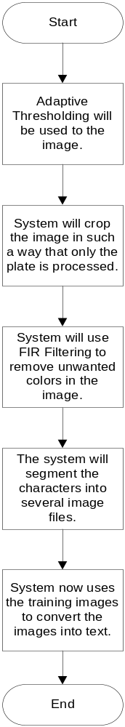
Figure 3-2. Digital Image Processing Flowchart
Assuming that the system converts the image correctly, the system will now go to the next phase of the car park system flow which is the database management of the system. The system now checks the the car inside the carpark and inputs the data obtained in the database. The system inputs the following data in the database : (1) Car Plate, (2) Time in and (3) Barcode Information.
Once the car wishes to leave the parking premises, the check-out phase of the parking system begins. Upon arrival at the checkout station, another sensor will detect the presence of the car and then repeat the same process of image processing in the check-in station. The system ,through the use of the barcode printed in the ticket, obtains the information of the car checking out and then compares it to the obtained data in the conversion process. If it matches, the car is now checked out of the parking system.

  - Digital Image Processing
    - Histogram
Histograms are one of the techniques used in image processing that is effective in enhancing the quality of an image. Histograms provide the statistics of a specific image. These statistics are used to determine the part of an image that is overexposed or underexposed. One of the other things that make the histogram popular in image processing is that normalizing the statistics of an image is quite easy to calculate. Aside from that, histograms are not only used for enhancing an image, but they are also used for compressing an image. Because of these features, the use of histograms can be very cost-effective. ^{[5]}
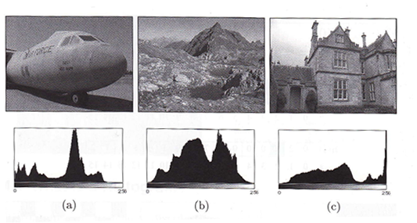
Figure 3-3. The difference in Histograms of different pictures.

As can be seen in Figure 3-1, different pictures have different variations of histograms. No two pictures have the same exact histogram. The images can vary in light exposure, noise and other factors that can affect the quality of the image.

    - Noise Cleaning
Since images are subjected to different kinds of noises at any point in time, some sort of noise cleaning technique should be utilized to produce an image that would free the image of all kinds of noise. More often than not, noise cleaning is easy to spot because of the fact that the pixels affected by noise are different from their neighbor pixels. Because of this assumption, noise cleaning algorithms have been easier to create.

      - Linear Noise Cleaning
Linear noise cleaning is done using a simple low-pass filter. In using a low-pass filter, concepts about convolution and the Fourier transform methods are usually used for noise cleaning. Fourier transform is usually used whenever the noise in the image is of high-frequency. In most cases, linear noise cleaning is used whenever the image to be processed contains continuous or uniform noise distribution. Because of this, however, this technique creates too much smoothing and blurs out the details of the image.

      - Nonlinear Noise Cleaning
Because linear noise cleaning gives too much smoothing on images with impulse noise, the quality of the image suffers greatly. Nonlinear noise cleaning is an effective method of smoothing a noisy image while retaining the details of an image. It is a very effective method in images that contain a uniformly distributed noise. ^{[11]}

    - Thresholding
Thresholding is one of the widely used techniques in image processing. The use of thresholding requires the principles of Histograms. In this method, the gray-level histograms are used. Through these gray-level histograms, a threshold, T, would be used as the basis to separate the background from the object of the picture itself. If the gray level exceeds the threshold value, it is considered as an object; otherwise, it is considered the background.

      - Global Thresholding
This is the simplest thresholding technique used in digital image processing. This technique is done by segmentation of the image and using the segmented image as the basic global threshold, T. Each pixel of the image is then labelled as the object or as the background. The gray level of the pixel to be labelled is then evaluated on whether it exceeds or goes below the value of T.

      - Adaptive Thresholding
Whenever an image contains uneven lighting, Histograms cannot be segmented, which would then make global thresholding ineffective. Luckily, adaptive thresholding technique can be the substitute. In this technique, the image is divided into small images, each having its own threshold. The only flaw in this technique is that it is difficult to approximate the threshold for each small image. ^{[12]}

    - Filtering
Filtering is similar in method to point operations in digital image processing. The only difference between these two is that filtering uses more than one pixel for computing the value of a new pixel. The main idea of filtering is to basically give the image a smooth feeling. Therefore, filtering the image would mean that changing a set of pixels to the average of those pixels.

      - Linear Filters
Linear filters are called that way because of the way they compute for the value of new pixels. These pixels just use a basic weighted summation for computing the value of new pixels. Just like any other filter, linear filters have a smoothing effect.
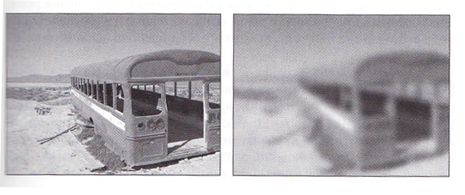
Figure 3-4. The difference between a slightly Non-filtered image and an overly filtered image.

As can be seen in Figure 3-2, making the filter size too big can already make the picture blurry. On the other hand, using a small-sized filter would still make the object clear as if no editing was performed.

      - Nonlinear Filters
Though linear filters are easy to use and to program, they have a big disadvantage when it comes to smoothing: edges, corners, lines, boundaries and the like are blurred as well. Because of this effect, linear filters are ineffective when it comes to noise cleaning. Nonlinear filters, however, are used for these instances.

    - Edges and Contours
Edges are very important in a person’s point of view. They help determine the shape of a specific object. The lack of edges can be disastrous in determining the figure of the edges. Edges are defined as where the local intensity of the object changes in digital image processing.
Contours, on the other hand, give the image a 3D effect. They give depth to the object portrayed in the image. In digital image processing, they are seen starting from a point in the image where the edge strength is high. This point is then traced until a closed object is formed. ^{[13]}

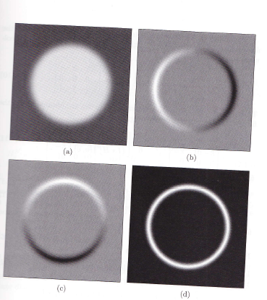
Figure 3-4. The image converted to form the edges and contours.
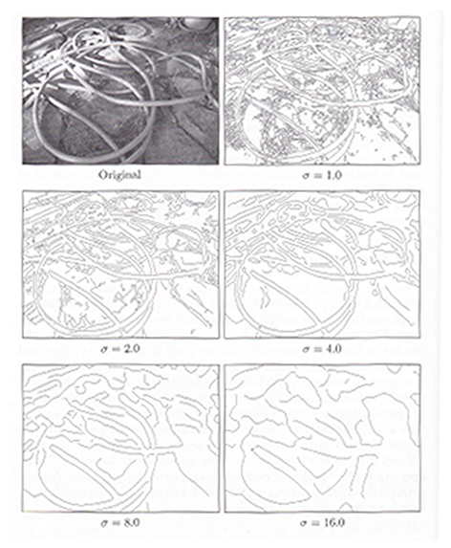
Figure 3-5. Getting the edges of the original picture using different values of σ.

Figure 3-4 shows that through a specific algorithm, the edges and contours of an image can be made visible. Figure 3-5 on the other hand, shows that by using a larger value for getting the edges and contour of an image removes the images that don’t necessarily have edges or contours. This, however, may blur out the image and make the edges and contours less visible.

  - Database Systems
    - Database Management Systems
A Database Management System or DBMS, is a compilation of data that uses a specific program to access the data inside the database. Database management systems are specifically created to efficiently retrieve and manage the data in the database. Aside from that, DBMS are also used to protect the data from system crashes or from hacking.

      - Data Abstraction
Data abstraction is the ability of a DBMS to retrieve the data efficiently. Data abstraction is seen in two different levels: the physical level and the logical level. The physical level describes how the data is stored in the database. The logical level shows the relationship a field of data to the other fields of the data.

      - Database Schema
The database schema of a database system is dependent on the levels of abstraction of the database itself. In most cases, it is seen in the physical schema and the logical schema. The physical schema is the design of the database at the physical level and the logical schema, meanwhile is the design of the database at the logical level. Most of the time, it is the logical schema that is given the most attention since its design affects the different applications to be used by the database. ^{[8]}

    - Relational Database
Relational databases are databases that use a number of different tables to show both the data in the database and the relationship of data between the other data seen in the database.

      - Relational Database Structure
The structure of relational databases consists mainly of a number of different tables with each table given a name unique from the other tables in the database. Each data in the table consists of a key unique from the other data in the table. This unique key would serve as the link between the different tables in the database.

      - Primary Keys
Primary keys play a vital role in relational databases. The primary keys define how each of the different tables in the database is distinguished from one another. These designate the individuality of the data in the database. In most cases, the name of a person is insufficient to be a primary key since there are a people who share the same name. As such, the name cannot be the primary key. Aside from that, the primary key of the person cannot, as much as possible, be changed. Because of this, the primary key must be carefully considered.

    - Database Design
Since most databases are used to store large amounts of data, it is necessary that design of the database be effective and efficient. The database design primarily consists of the design of the database schema itself, and predicting the issues that database may encounter in the future.

      - The Entity-Relationship Model
The entity-relationship model is basically the data found in the database called entities and its relationship with one another. Entities are defined by different attributes, depending on what the database is about. Aside from the different attributes, entities contain a unique attribute that would distinguish it from other entities in case there are two entities that have one or two attributes similar among them. ^{[9]}

  - Software Used
    - MySQL
MySQL (SQL stands for Standard Query Language), founded and developed by David Axmark, Allan Larsson, and Michael Widenius, is the most popular open source database and is included in the LAMP Stackwhich includesthe following open source applications/softwares: Linux, Apache, MySQL, PHP / Perl / Python. MySQL has become a preferred choice of database system management especially for web applications.It is a relational database management system that provides multi-user access to databases from a server run by MySQL.Many of the applications we see today in the internet, like Facebook, are powered by MySQL for their database needs.
MySQL can run in different platforms including Linux and Windows. Many of the programming languages used by the developers have libraries for integrating MySQL databases with the choice of programming language. C# and Visual Basic of Microsoft’s Visual Studio uses MySQL Connector/Net for integrating MySQL into these programming languages. In addition, world’s most popular programming language, Java, uses JDBC driver for MySQL integration.
Like any other applications, MySQL has its own Graphical User Interface (GUI) tools to administer MySQL databases or manage data. The official free integrated environment developed by MySQL AB is the MySQL Workbench which enables the users to manage (1) Database designs, (2) SQL Development, and (3) Database administration.
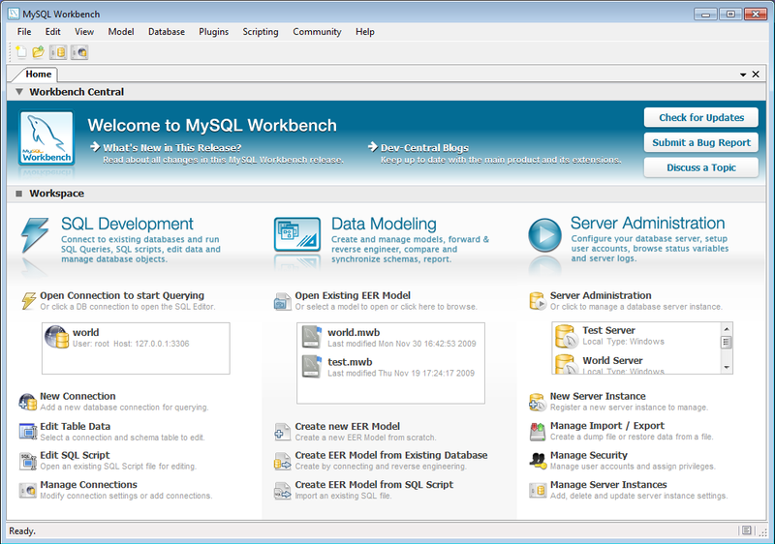
Figure 3-6. MySQL Workbench GUI

    - Openoffice.org
OpenOffice.org is an open-source, multi-language productivity suite which provides applications for word processing, spreadsheets, presentations, graphics, and databases. It is an alternative for the most popular paid productivity suite, Microsoft Office. OpenOffice.org is available on almost all types of operating system since it runs with the Java Runtime Environment.OpenOffice.org supports ISO/IEC standard OpenDocument Format (ODF) and file formats used by Microsoft Office.

Some of the compatible systems for Openoffice.org are:
- FreeBSD: v3.2.1
- Linux
- OpenBSD
- NetBSD
- Solaris: v3.2.1
- Mac OS X v10.2: up to v1.1.2
- Mac OS X v10.3: up to v2.1
- Mac OS X v10.4–v10.5 (PowerPC): up to v3.2
- Mac OS X v10.4–v10.5 (Intel): v3.2
- Mac OS X v10.6: v3.2.1
- Windows 95: up to v1.1.5
- Windows NT 4.0 Service Pack 6 – up to v2.0.1
- Windows 98 – Windows ME: up to v2.4.3
- Windows 2000 – Windows 7: v3.3 (Tablet PC input is not supported)
- OS/2 and eComStation: up to v3.2.0
- IRIX (mips4): up to v1.0.3

    - OpenOffice.org Base
OpenOffice.org Base is the Java-based, database application of OpenOffice.org, which is highly comparable to Microsoft’s database application, Microsoft Access.OpenOffice.org Base uses HSQL which is a variety of the original SQL. Creating database using Base can be done through command line or GUI. OpenOffice.org Base is a free software, open-source and is released under the terms of the GNU Lesser General Public License.

OpenOffice.org Base can be used as a fronted GUI for external SQL Databases such as MySQL, PostgreSQL, and Oracle through Open Database Connectivity (ODBC) which is written in C language or Java DataBase Connectivity (JDBC) which is written in Java language. OpenOffice.org Base GUI provides functions for (1) SQL views, (2) table-design, and (3) query.

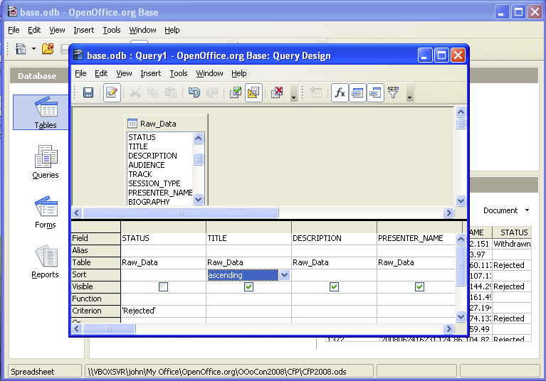
Figure 3-7. Openoffice.org Base GUI

    - Java
Java is one of the most popular object-oriented programming languages used by developers today. Java is so popular that almost everything we used is already powered by Java; it has 9 million developers, 1 Billion downloads per year, and 3 Billion Devices run Java^{[14]}.Java is an open-source programming language chosen by many developers to work with because Java applications can run in any device that has Java Virtual Machine (JVM) regardless of the computer architecture used for that device. Java language is built on five principles that are manifested in every Java application and system:
- It should be "simple, object-oriented and familiar"
- It should be "robust and secure"
- It should be "architecture-neutral and portable"
- It should execute with "high performance"
- It should be "interpreted, threaded, and dynamic"

Java’s syntax is based on C++ language which is also an object-oriented language like Java.
Almost everywhere around us is powered by Java; from smartphones to robots. Its popularity defined the world of open-source applications which require no royalties to anyone.

    - Java Development Kit
Java Development Kit is the Software Development Kit product of Sun Microsystems which enables the developers to create Java-based applications. JDK is released under the GNU General Public License which makes JDK free software that anyone can use.
Java Runtime Environment
Java Runtime Environment is Java’s execution environment of Java-based applications. It is included in JDK and includes the Java Virtual Machine, standard core set of libraries, and other supporting files needed to execute a certain Java application.
Java was originally designed by James Gosling of Sun Microsystems and released on 1995.

    - Java 2D™ API

Java 2D™ is an Application Program Interface which improves the graphics, text, and imaging capabilities of the Abstract Windowing Toolkit. Java 2D™ API includes good graphics processing tools which allows developers to create sophisticated algorithms and functions with Java. Image processing in Java always use the concept of Java 2D™ to manipulate images by manipulating pixels. Java 2D rendering capability is provided by the Graphics object of Java; this provides the rendering methods for a certain graphics.^{[16]}

    - JavaOCR
JavaOCR is an Optical Character Recognition application written in Java and developed by Ron Cemer. JavaOCR is released under BSD License, thus making it open-source and free. The OCR engine of this application is compiled in a Java library which can be reused for other Java application packages of other developers which needs JavaOCR.
Java OCR is simple to use but offers effective implementation since it uses least square error matching algorithm that allows automatic position and aspect ratio correction. ^{[15]}

  - ImageJ
ImageJ is a free software that is used to create, visualize, edit, process, analyze, load and storage images. Developed and maintained by Wayne Rusband at the U.S. National Institutes of Health, ImageJ is software that has ready-made tools that can be used for image processing. But at the same time, it can also be used to write new software components in a real programming language.
ImageJ is implemented in Java, making it easier for students and programmers to use this software since Java is one of the most popular programming language. Also, ImageJ is a free software, allowing programmers to install and use this software legally, even without license charges.
ImageJ is largely platform independent, still running even without the modification from operating systems such as Windows, MacOS and Linux. The use of Java for ImageJ also allows plugins to be independent pieces of Java code that can be compiled.
The current version of the ImageJ software can open image formats such as uncompressed TIFF, JPEG,GIF, PNG and BMP.
Present day laboratories and institutions around the world such as biological and medical imaging use this software because of its extensive features. It is easy to use, free of any charge and flexible to the wants of the programmers. Thus, making it the ideal platform for digital image processing.^{[13]}

  - Image Size and Resolution
The size of an image can be determined through the use of a matrix system. The size of image matrix I is m x n, wherein m is the number of columns of matrix I, and n is the number of rows of matrix I.
The resolution of an image is the number of spatial dimensions of an image in the real world. Normally, the resolution of an image is used for measurements. Units such as dots per inch (dpi) or lines per inch (lpi) are obtained by getting the resolution of an image. ^{[13]}

  - Image Coordinate System
To be able to know and to manipulate the element of the image, the use of a coordinate system is necessary. In digital image processing, the coordinate system will be implemented in an image matrix I that contains m x n elements. The image coordinate system works just like that of the xy coordinate system, the only difference is that the origin of the image coordinate system is located on the top most left element and the y-coordinate runs from top to bottom of the image matrix I.^{[13]}
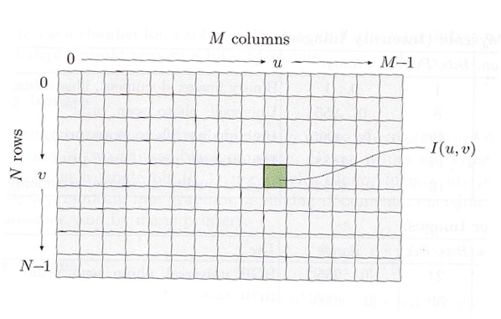
Figure 3-8. Image Coordinate System

  - Pixel Values
The pixel value of an image is defined to be the binary word with a length of k. The number of possible values of an image is defined to be as 2^{k}, while the value of an image ranges from 0 to 2^{k} -1. ^{[13]}
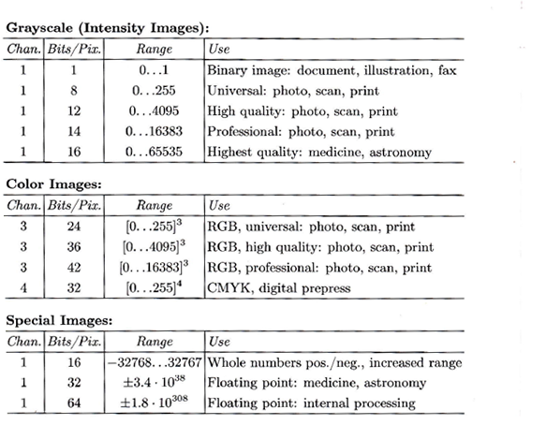
Figure 3-9. Image element ranges and their typical applications domain

    - Grayscale Images (intensity Images)
Grayscale images are images that have a value that represents the intensity, brightness and the density of an image. A typical grayscale image uses k=8 bits or 1 byte per pixel. This kind of image uses a value that ranges from 0 to 255, with 0 being the darkest which is the color black and 255 with being the brightest which is color white. Grayscale images will not contain a negative value because the brightness of an image can never be represented by a negative value.^{[13]}

    - Binary Images
Binary images are images that have only two possible values, 0 or 1. Therefore, these images usually contains only 1 bit per pixel. Binary images are normally used in applications such as line graphics representation, archiving documents, encoding fax transmissions and usually used by printers.^{[13]}

    - Color Images
Color images are the type of images that use three primary colors: Red, green, and blue (RGB). Usually, each primary color is represented by an 8 bit binary value, thus allowing the manipulation the intensity and the brightness of each of the primary color. Because there are three primary colors, each pixel contains 24 bits of binary value (8 bit / primary color x 3 primary colors). The manipulation of the intensity and the brightness of each color is necessary so that other colors aside from the RGB can be produced such as: Cyan, Magenta, Yellow, Black and White.^{[13]}

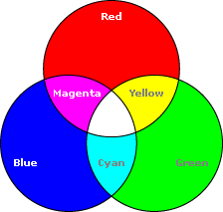

Figure 3-10. CMYB Model

    - Special Images
Special images are type of images that does not contain the attributes of a grayscale, binary, and color images. These images contain a negative and floating point value. Negative value occurs when the image undergoes digital image processing such as edge detection, while floating point values are necessary in fields such as medicine and astronomy for a more precise and accurate values.^{[13]}

  - Image File Formats
Image file format is one of the most important decisions a programmer has to make in image processing. Certain considerations such as the type of image, storage size and compression, compatibility and application domain must be considered before deciding which image file format is appropriate for the application.^{[13]}

    - Tagged Image File Format (TIFF)
Tagged Image File Format is a type of image that developed by Aldus, later on by Microsoft and now Adobe. This type of image supports grayscale, indexed, and true color images. The strength of TIFF is its flexibility, new image types and information block can be created by defining new tags. But at the same time, this flexibility is also its weakness. Not all proprietary tags are supported, leading to an error commonly seen, the “unsupported tag”. Another disadvantage is that currently, no web browser supports this type of format.^{[13]}

    - Graphics Interchange Format (GIF)
Graphics Interchange Format or commonly known as GIF is a image type that was developed by CompuServe in 1986. It has grown into one of the most common and popular image type that is used for images on the web. One of the reasons why it has grown popular is because of its ability to animate by storing a number of images in a single file for sequential display. GIF files support color and gray scale images with a maximum depth of 8 bits, but it does not support true color images. GIF files usually use less memory space compared to other file formats because it can enable the encoding of pixels using fewer bits.^{[13]}

    - Portable Network Graphics (PNG)
The portable network graphics or PNG was developed to serve as a replacement for GIF files. This was because GIF files faced licensing issues. PNG format supports true color, grayscale and indexed images. To sum it all up, PNG format surpasses all the capabilities of the GIF format. The only capability that PNG cannot achieve is the ability to create a simple animation. ^{[13]}

    - JPEG
JPEG , developed by the Joint Photographic Experts Group in 1990, is a method used to compress image data. It was originally developed to achieve an average data reduction of 1:16. JPEG achieves the compression to 1 bit per pixel (1:25). This type of image supports 256 color components and the CMYK images.^{[13]}

    - JFIF
JFIF, JPEG File Interchange Format, is a file developed by Eric Hamilton and the Independent JPEG group. This type of format is almost always the instance of a JPEG file. The JFIF defines the remaining necessary elements of a file format. ^{[13]}

    - Exchangeable Image File Format (EXIF)
The exchangeable Image File Format , developed by the Japan Electronics and Information technology Industries Association, is a modification of the JFIF format. This type of format is used to store image data from digital cameras. Currently, almost all manufacturers of digital cameras use this type of format to store digital images on memory cards. In this type of format, the metadata information uses TIFF, while JPEG is used to encode a thumbnail preview image. This was done so that JPEG/JFIF readers can read this type of format without any problems.^{[13]}

    - JPEG-2000
JPEG-2000 format was designed in order to overcome some of the weaknesses of the tradition JPEG codec. One of the most significant improvements of this format is its ability to compress image data up to 0.25 bit / pixel on RGB color images. But as of now, only few image processing applications and web browsers support this type of format.^{[13]}

    - Windows Bitmap (BMP)
Windows Bitmap, developed by windows, is a simple format that supports grayscale, indexed, and true color images. Although it can also support binary images, using this type of format for binary images is not advisable, because it still uses an entire byte for each pixel which makes it inefficient. ^{[13]}
    - Portable Bitmap Format (PBM)
The Portable Bitmap Format is a family of simple file formats that can be saved in a human-readable text format. It can be edited using a text editor. This type of format is widely used under Unix and supports the following formats: PBM (Portable bitmap) for binary bitmaps, PGM (Portable graymap) for grayscale images, and PNM(portable anymap) for color images.^{[13]}

  - Barcode
Barcodes are commonly used in processes that require large-scale inventory. Normally items with barcodes are found in merchandises that allow the owners to keep track of the items and to easily access information about the item such as price.
Barcodes are composed of 95 evenly spaced columns, each represented by a binary bit. These are bits are determined to be 1 or 0 through light reflection. If the reader detects a significant amount of light reflected, then the specific bit is defined as a ‘0’ while if there is no light reflection detected, it is defined to be as ‘1’.
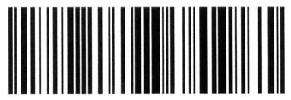
Figure 3-11. Sample Barcode
REFERENCES
^{[1]} Pala, Zeydin and Nihat Inanc. "Smart Applications Using RFID Technology." RFID Eurasia, 2007 1st Annual (2007): 1-3.
^{[2]} Tang, Vanessa, Yuan Zheng and Jiannong Cao. "An Intelligent Car Park Management System based on Wireless Sensor Networks." 1st International Symposium on Pervasive Computing and Applications (2006): 65-70.
^{[3]} Chen, Li-Chih, et al. "Vision-Based Vehicle Surveillance and Parking Lot Management." 2010 Sixth International Conference on Intelligent Information Hiding and Multimedia Signal Processing (2010): 631-634.
^{[4]} Wilhelm, B., Burge, M.J. Principles of Digital Image Processing. London. 2009.
^{[5]} Bovik, A. The Essential Guide to Image Processing. San Diego, California. 2009.
^{[6]} Booker, G. Sensors for Ranging and Imaging. SciTech Publishing Inc. 2009.
^{[7]} Soloman, S. Sensors and Control Systems in Manufacturing. McGraw-Hill Companies, Inc. 2010.
^{[8]} Riordan, R. M. Designing Effective Database Systems. New Jersey. 2005.
^{[9]} Rob, P., Coronel, C. Database Systems. Canada. 2007.
^{[10]} Silberschatz, W., et. al. Database System Concept. McGraw-Hill. New York. 2011.
^{[11]} Pratt, W.K. Digital Image Processing. Wiley Interscience. 2007.
^{[12]} Gonzalez, R.C, et. al. Digital Image Processing. Prentice Hall. New Jersey. 2002.
^{[13]} Burger, W. , et. al. Digital Image Processing : An Algorithmic Introduction Using Java 1st Ed. .Springer Science+Business Media, LLC. New York, 2008
^{[14]} http://java.sun.com/docs/white/langenv/Intro.doc2.html (retrieved October 13,2011)
^{[15]} http://www.roncemer.com/software-development/java-ocr (retrieved October 13,2011)

^{[16]}http://download.oracle.com/javase/6/docs/technotes/guides/2d/spec/j2d-intro.html#wp62980 (retrieved October 13,2011)

